# 1.25G SMF BIDI SFP Transceiver, 20km,

**T1310/R1550nm**

The WTGSFP-LX-20i is a high performance, cost-effective SFP transceiver. It provides up to 1.25 Gbps bi-directional data transfer rate at distances up to 20km on a single fiber core. These bi-directional SFP Transceivers allow data transfer in either direction through a single optical fiber by employing separate wavelengths travelling in either direction.

The WTGSFP-LX-20i transmits using a wavelength of 1310nm and receives using a wavelength of 1550nm. When coupled with the WTGSFP-LX-20i transceiver which transmits at and receives at the opposite rates (1310nm TX and 1550nm RX) you get bi-direction data communication on a single fiber core.

`

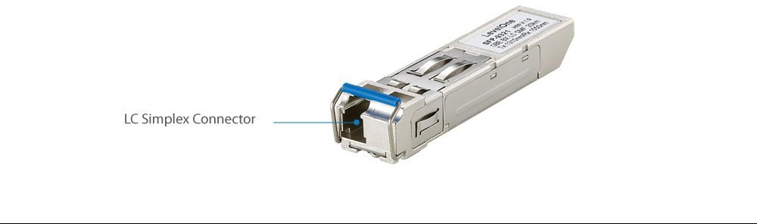

**Key Features**

* 1310nm FP LD
* Multi Data Rate: from 125M to 1.25Gbps, NRZ
* Single +3.3V Power Supply
* RoHS Compliant and Lead-free
* AC/AC Differential Electrical Interface
* Compliant with Multi-Source Agreement (MSA)
* Simplex LC Connector
* Compliance with specifications for IEEE-802.3z Gigabit Ethernet at 1.25Gbps
* Compliance with ANSI specifications for Fiber
* Channel applications at 1.06bps
* No configuration or installation software required

Dimensions (W x D x H

mm): 13.7 x 56.5 x 8.95 mm

Weight (g): 20g

Envoirnmental

Temperature (°C): Operating: 0°C ~ 70°C Storage: -40 ~ 85°C

Humidity

(Non-condensing): 5 ~ 95%

Power: -8~ -3 dBm

Transmission

Optical

Data Transfer Rate:

1.25 Gbps Bi-directional data link

Operating Distance: up to 20km (9/125?m)

Fiber channel up to 1.06Gbps

Sensitivity: -23 dBm

Power Budget: 15 dB

Power:

Supply Voltage: 3.3V

Max Voltage/Current: 6V/300mA General:

Hot-swappable

Receive

Optical

Specification.

Standards & Protocols:

IEEE 802.3ah 1000BASE-BX10-U SFP

Multi-Sourcing Agreement(MSA)

Connectors and Cabling:

Simplex LC Connector, Single-mode fiber(SMF)

Wavelength(nm):

T 1310nm / R 1550nm